Post-Workout Snack Example #1

1- 4” bagel (49g carbs, 9g protein)

2 tbsp. strawberry jam (26g carbs, 0g protein)

1 medium banana (27g carbs, 1g protein)

20oz Gatorade (34g carbs, 0g protein)
Additional water to meet needs

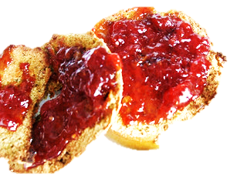
MEAL TOTALS: 136g carbs, 10g protein

Post-Workout Snack Example #2

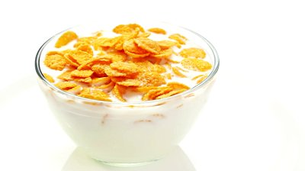
1 cup cornflakes (24g carbs, 2g protein)

1 cup skim milk (12g carbs, 8g protein)

2- 1.5oz box of raisins (68g carbs, 2g protein)
12oz Gatorade (21g carbs, 0g protein)
Additional water to meet needs
MEAL TOTALS: 125g carbs, 12g protein
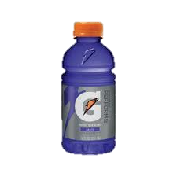
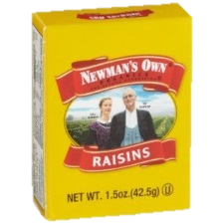
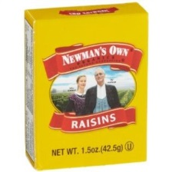

Post-Workout Snack Example #3

1 Oatmeal Raisin PowerBar (45g carbs, 8g protein)

1 cup pineapple chunks (22g carbs, 1g protein)

1 medium banana (27g carbs, 1g protein)
17 pretzels (23g carbs, 2g protein)
Water to meet needs

MEAL TOTALS: 117g carbs, 12g protein

Post-Workout Snack Example #4

1 cup (8oz) chocolate milk (26g carbs, 8g protein)

2-1.5oz box of raisins (68g carbs, 2g protein)

1 Nutri-Grain Cherry bar (24g carbs, 2g protein)
Water to meet needs

MEAL TOTALS: 118g carbs, 12g protein

Post-Workout Snack Example #5

2 Cinnamon-Raisin English muffin (56g carbs, 10g protein)

3.9oz container apple sauce (13g carbs, 0g protein)

2 Florida oranges (34g carbs, 2g protein)
12oz Gatorade (21g carbs, 0g protein)
Additional water to meet needs

MEAL TOTALS: 124g carbs, 12g protein

Post-Workout Snack Example #6

2 cups Special K Red Berries cereal (50g carbs, 4g protein)

2 medium bananas (54g carbs, 2g protein)

1 6oz light yogurt (16g carbs, 5g protein)
Water to meet needs

MEAL TOTALS: 120g carbs, 11g Protein

